10) Write a PL/SQL program for calculating the factorial of a given number.

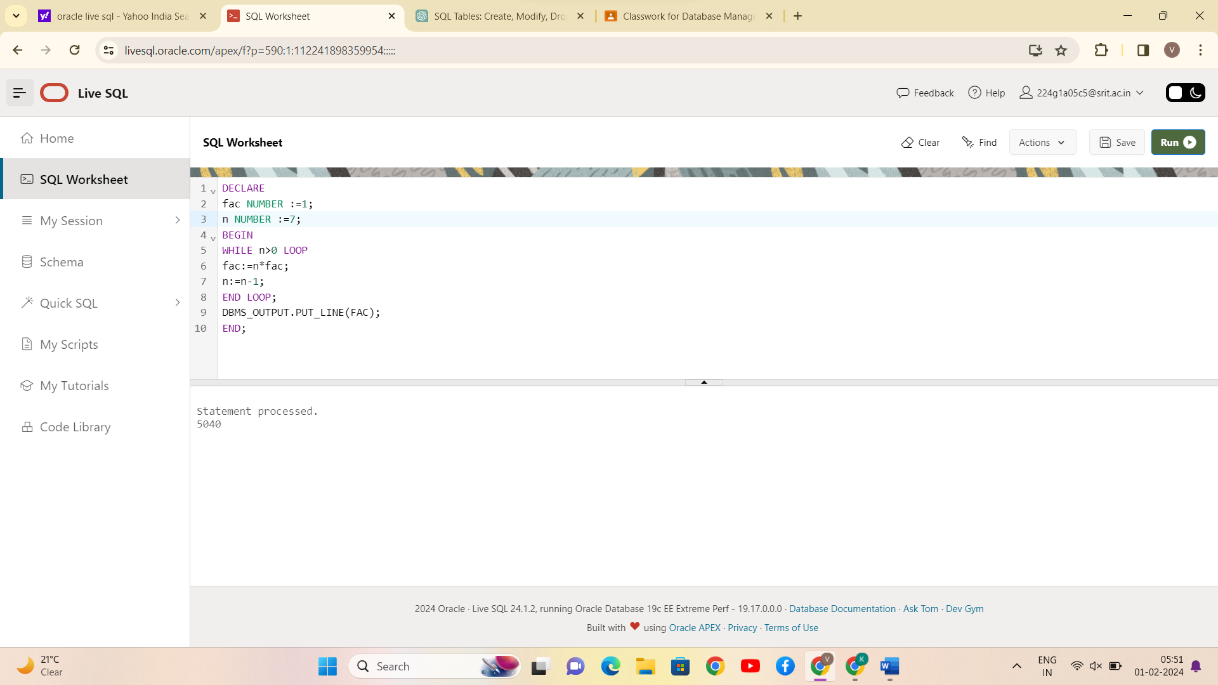

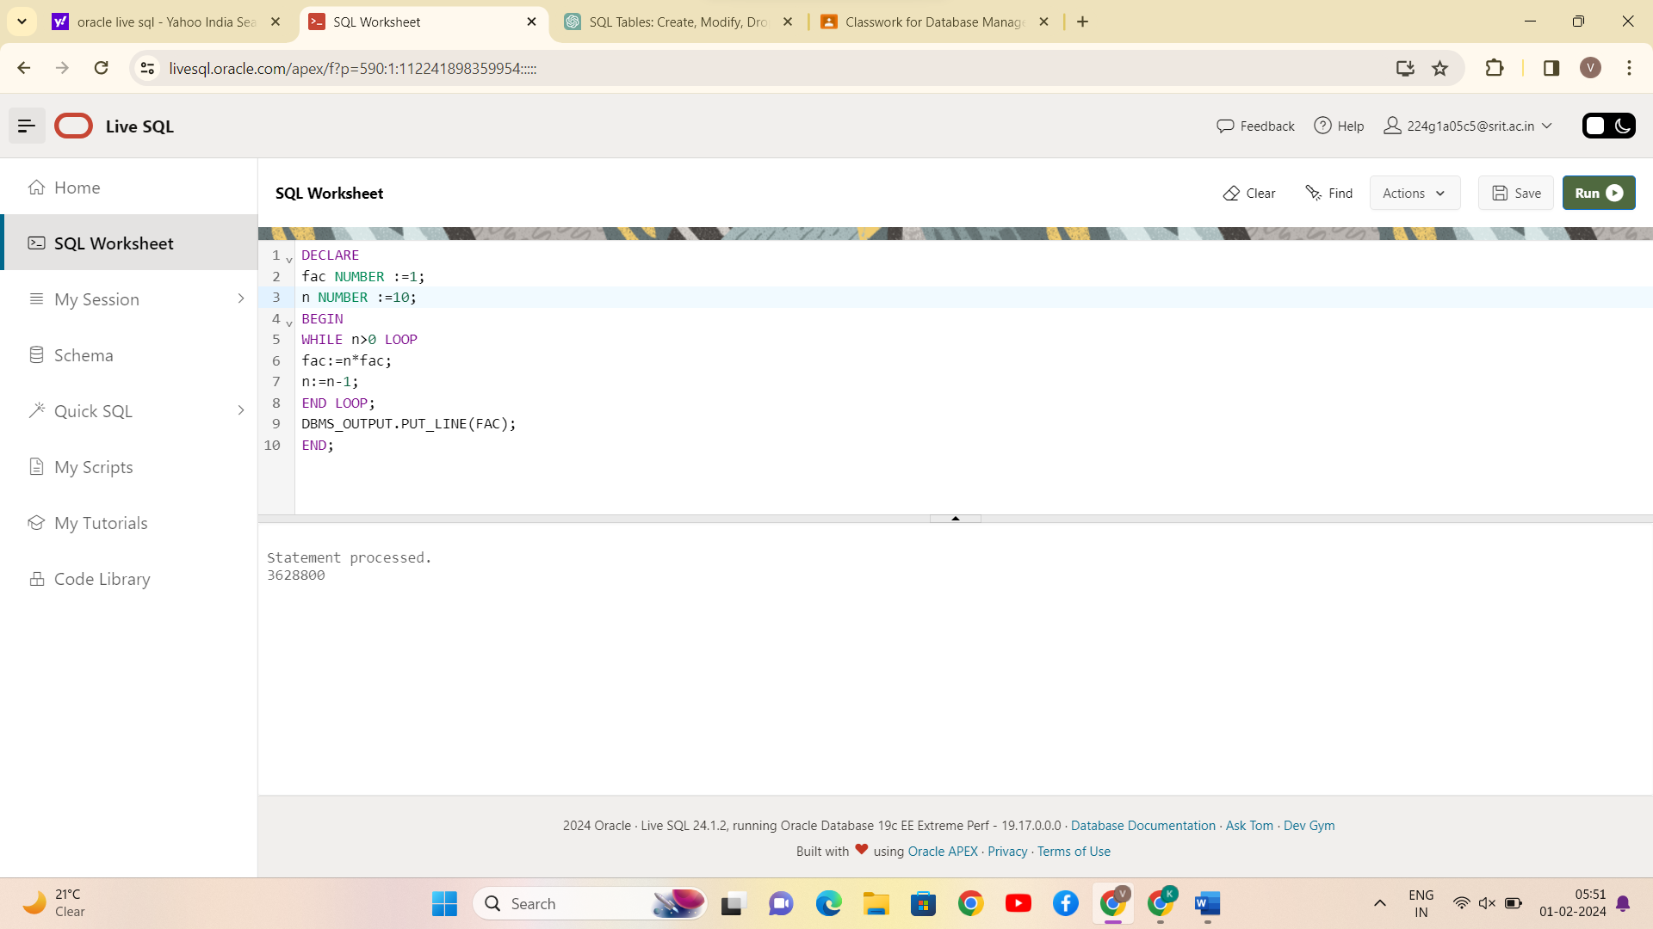

CONCLUSION:

PL/SQL program for calculating the factorial of a given number is successfully completed.

11) Write a PL/SQL program for finding the given number is prime number or not.

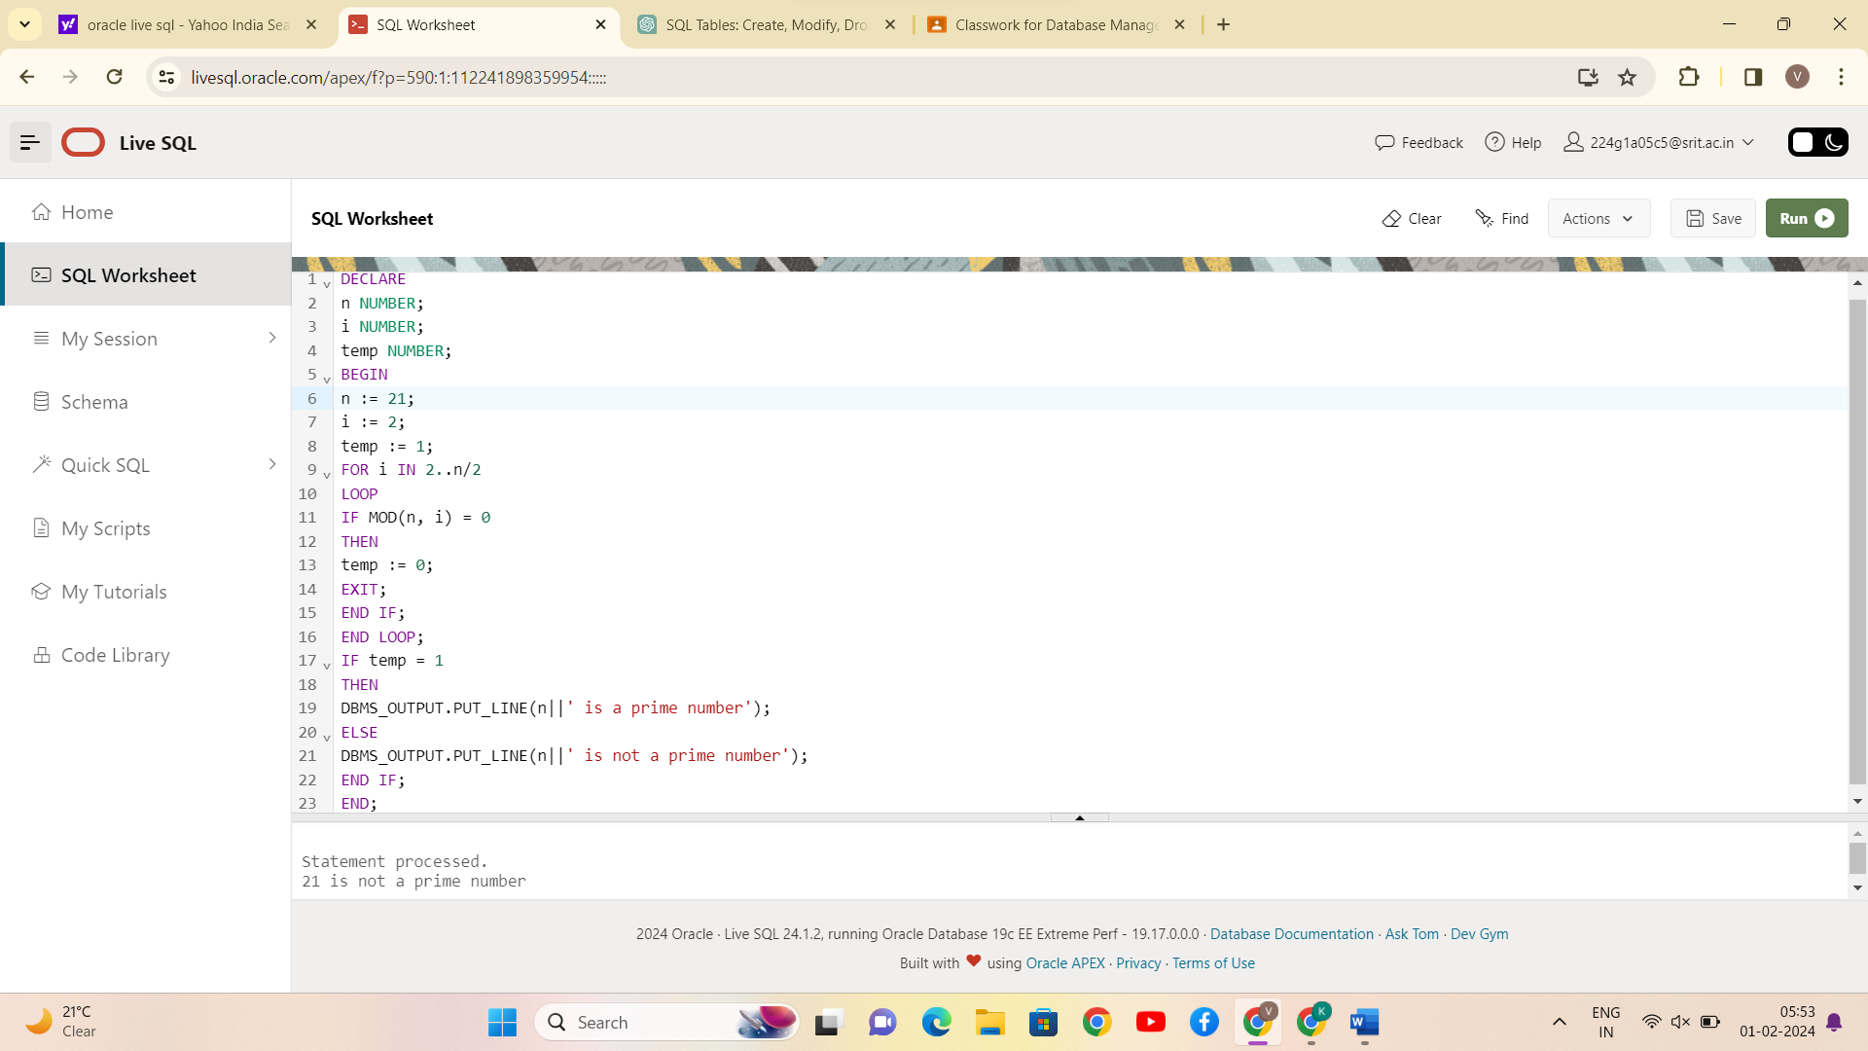

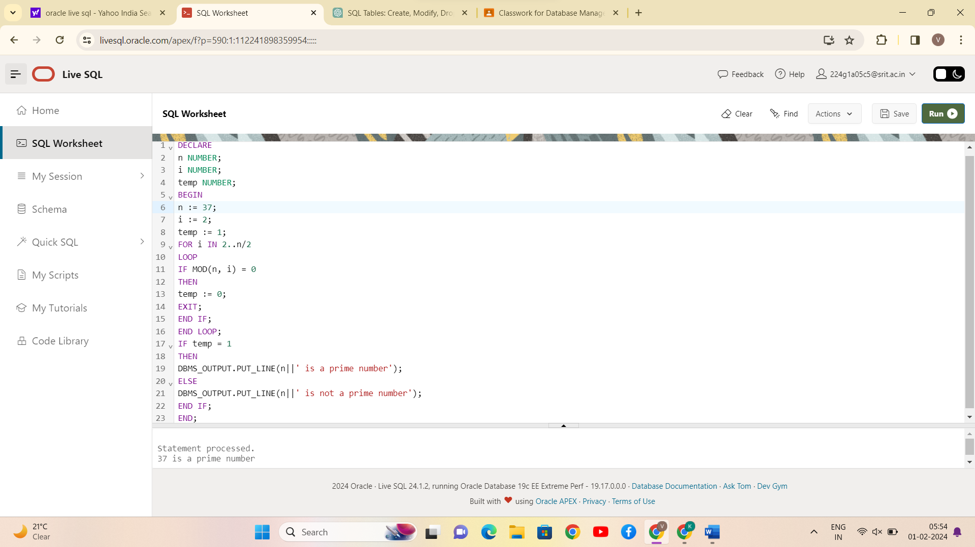

**CONCLUSION:**

**PL/SQL program for finding the given number is prime number or not is successfully completed.**

1. **Write a PL/SQL program for displaying the Fibonacci series up to an integer.**

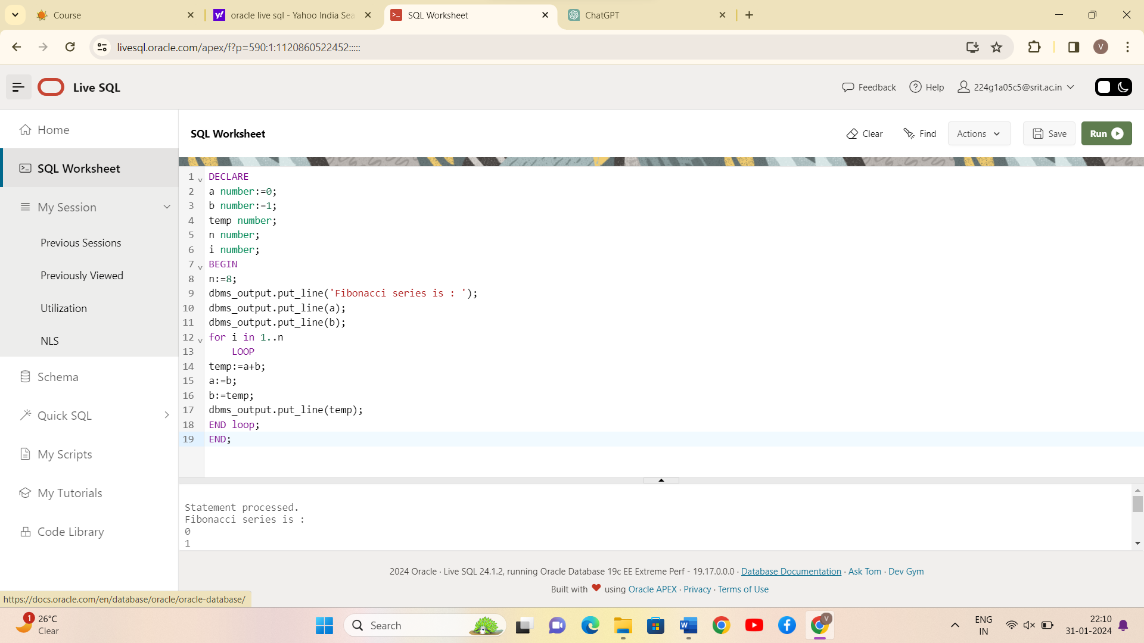

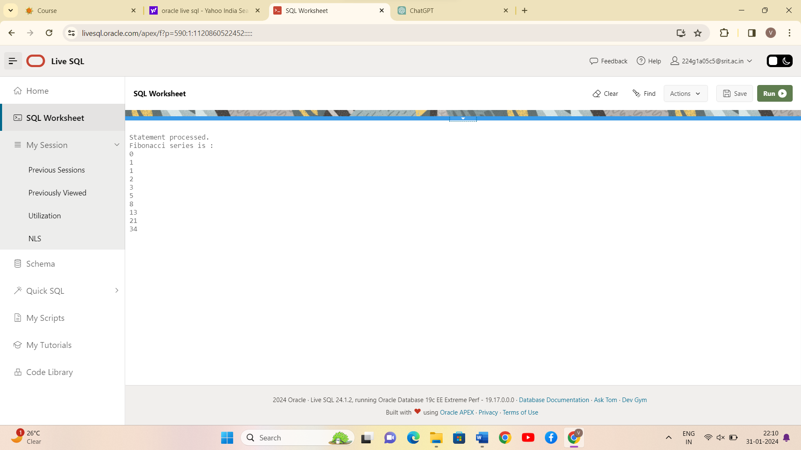

CONCLUSION:

PL/SQL program for displaying the Fibonacci series up to an integer is successfully completed.

13)Write PL/SQL program to implement Stored Procedure on table.

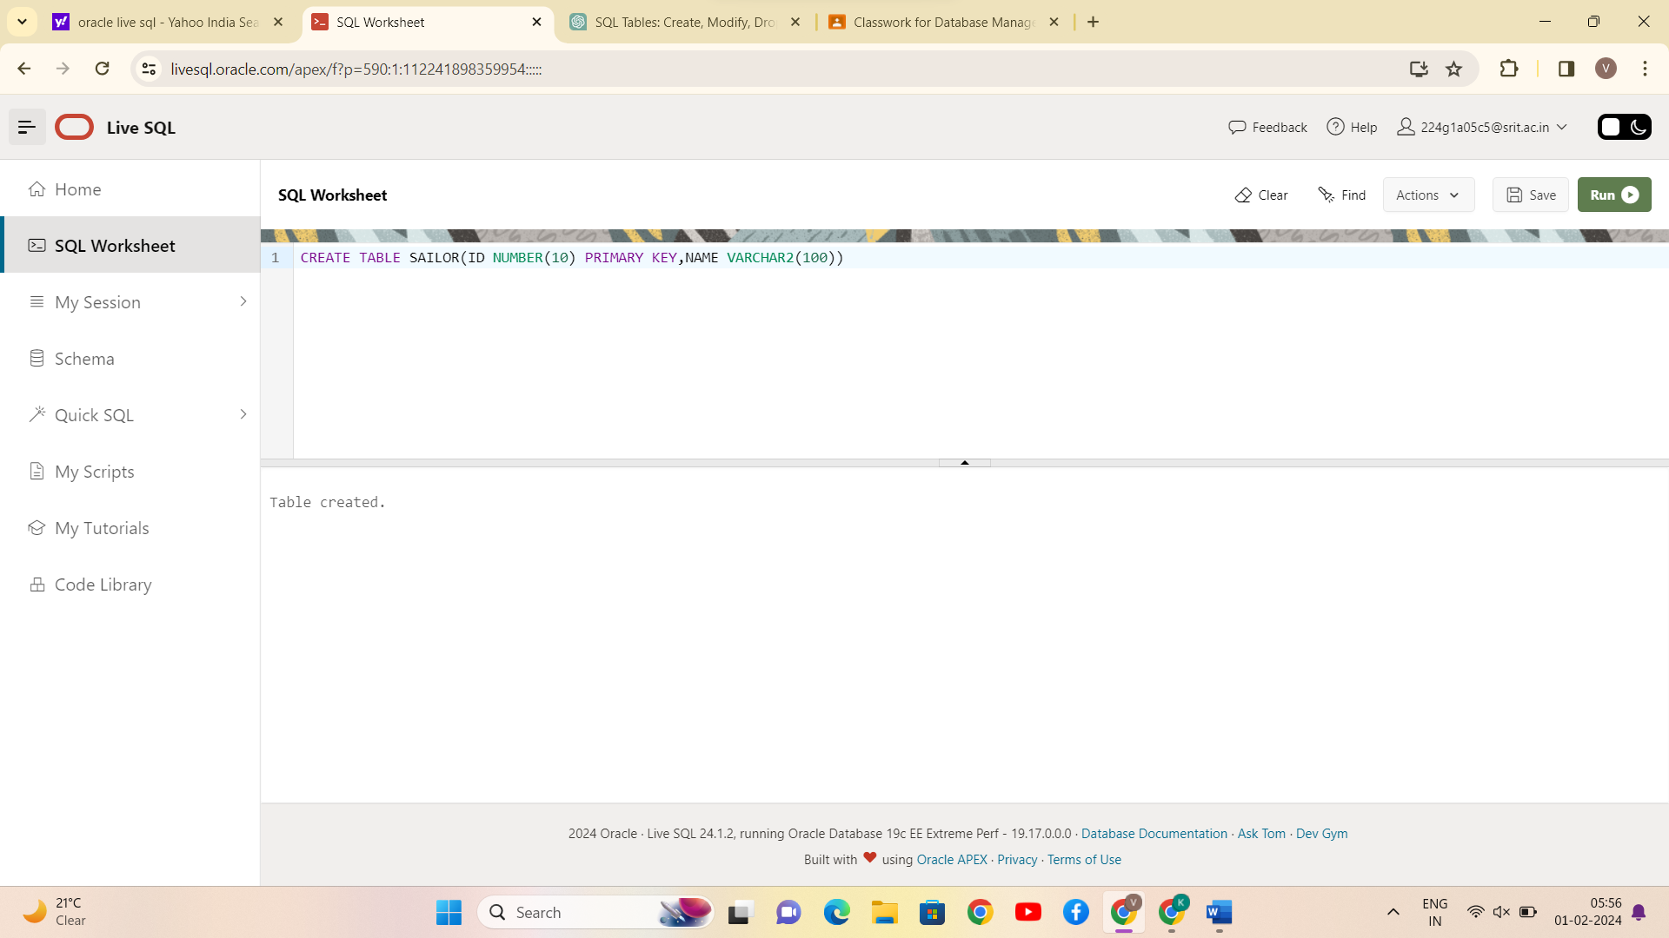

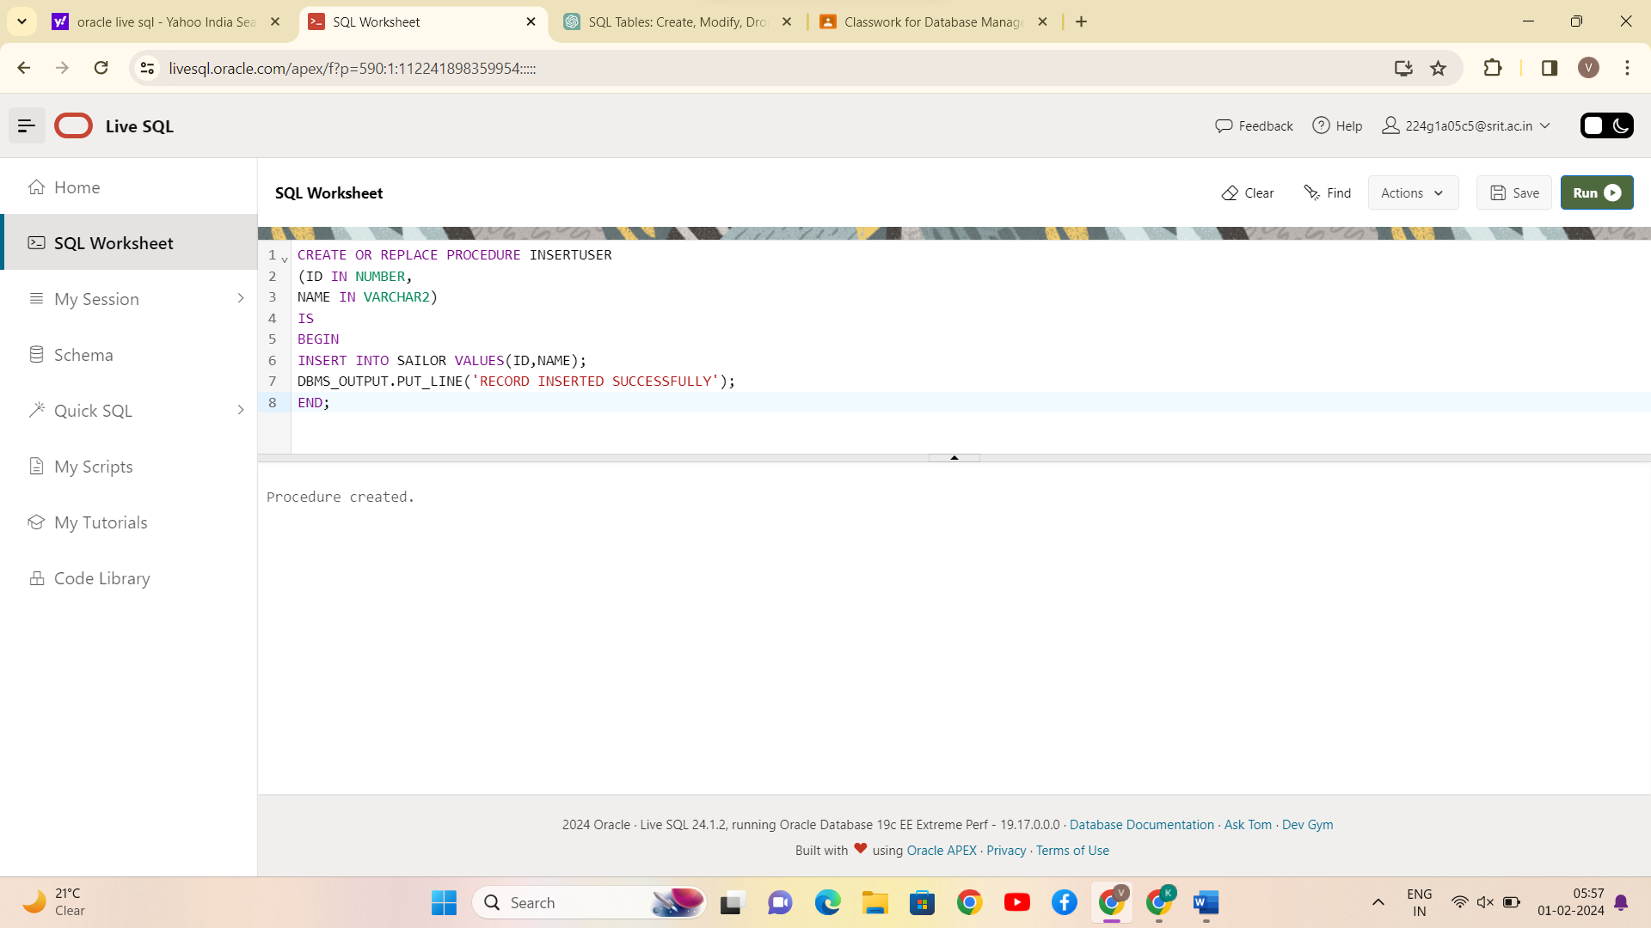

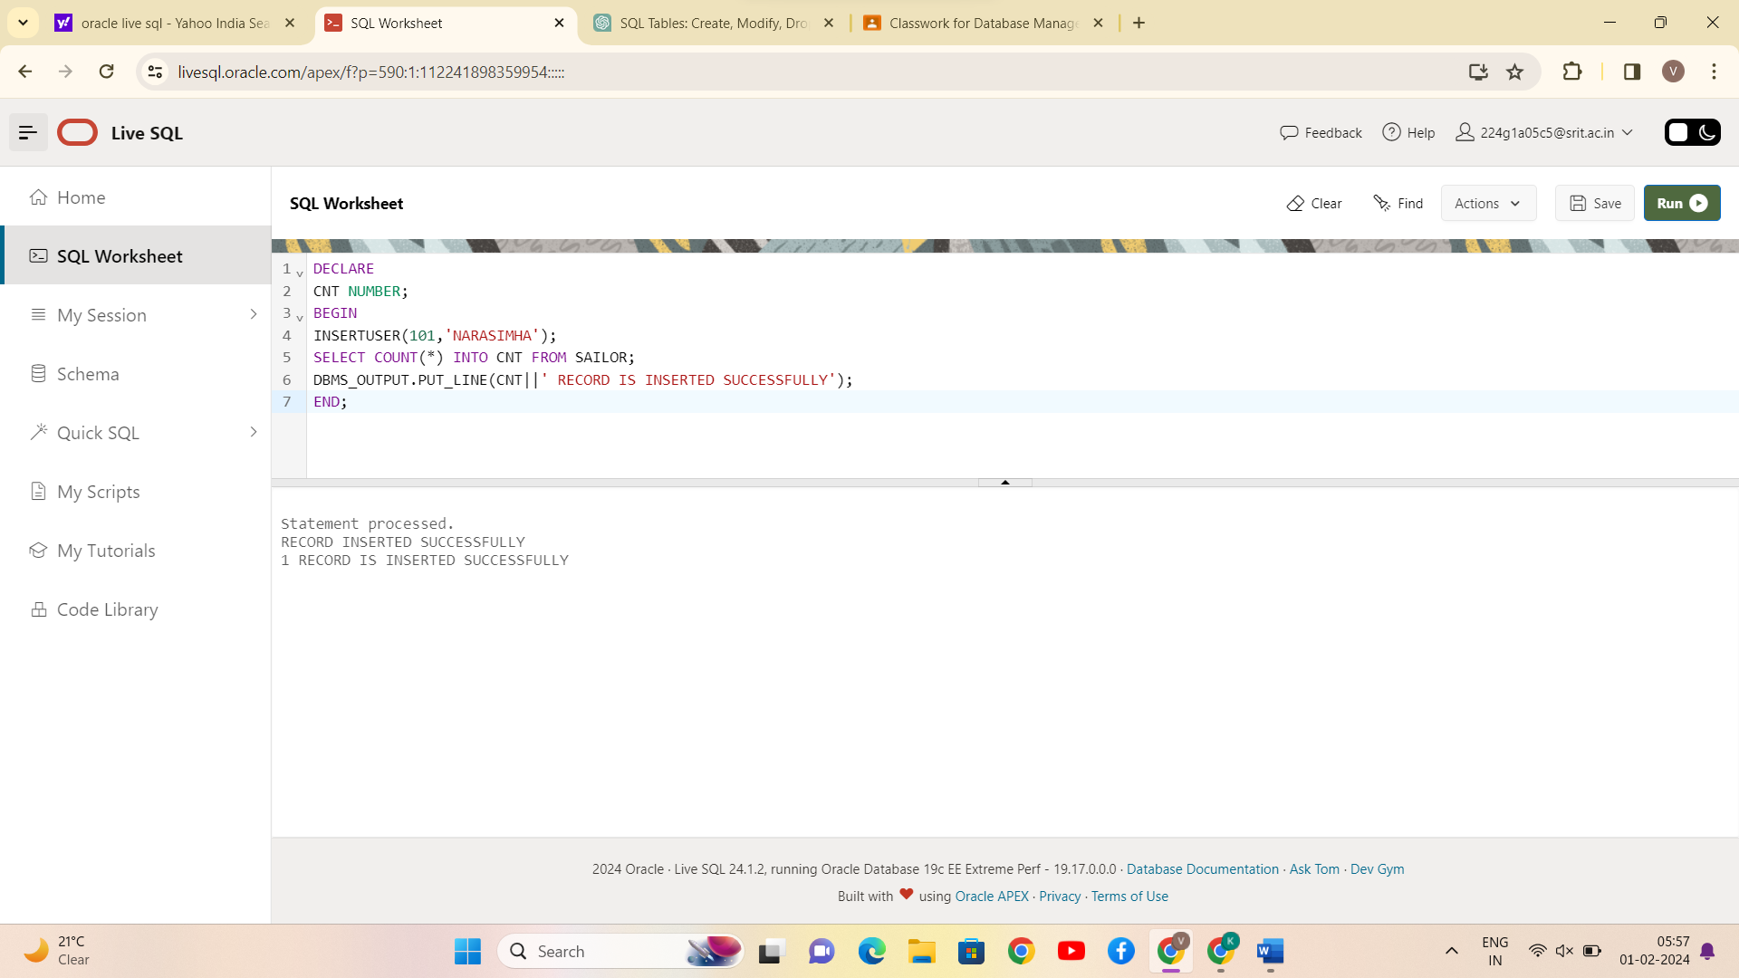

CONCLUSION:

PL/SQL program to implement Stored Procedure on table is successfully completed.

1. Write PL/SQL program to implement Stored Function on table.

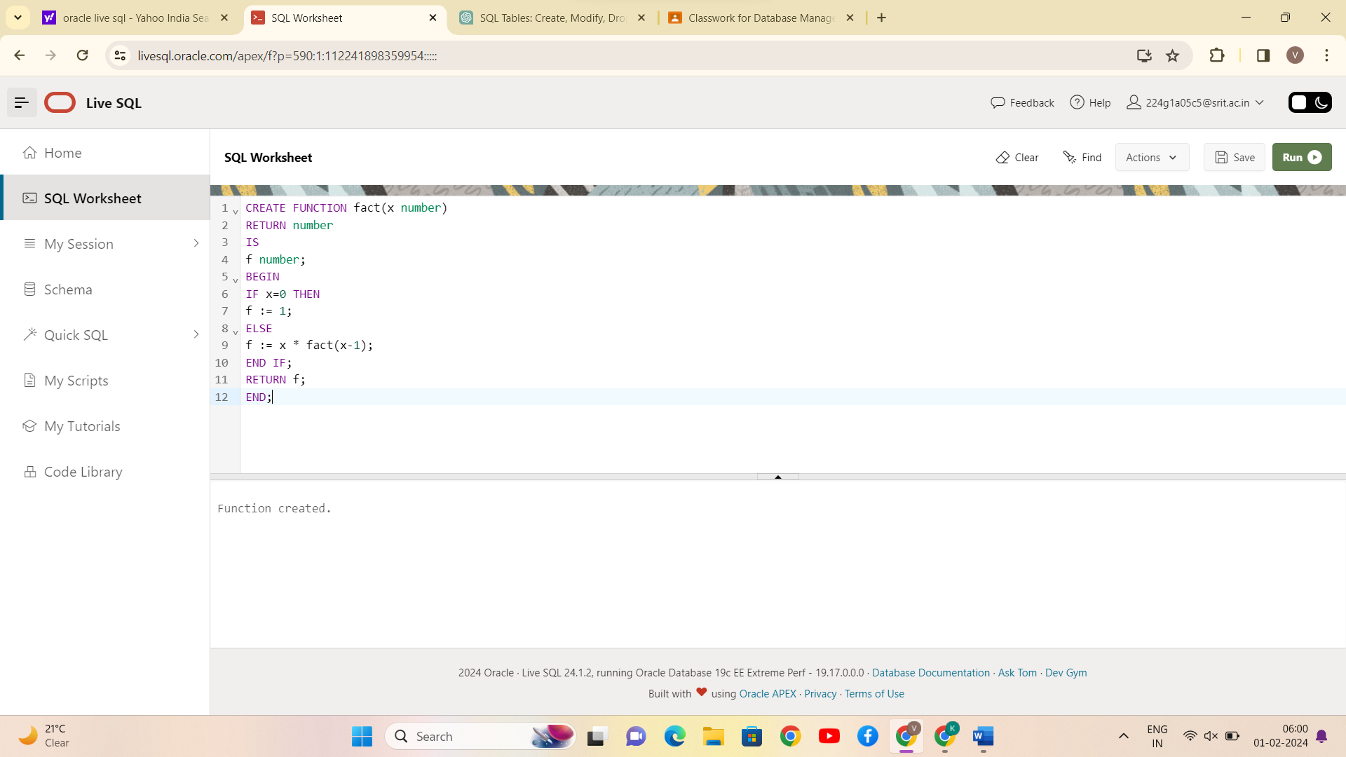

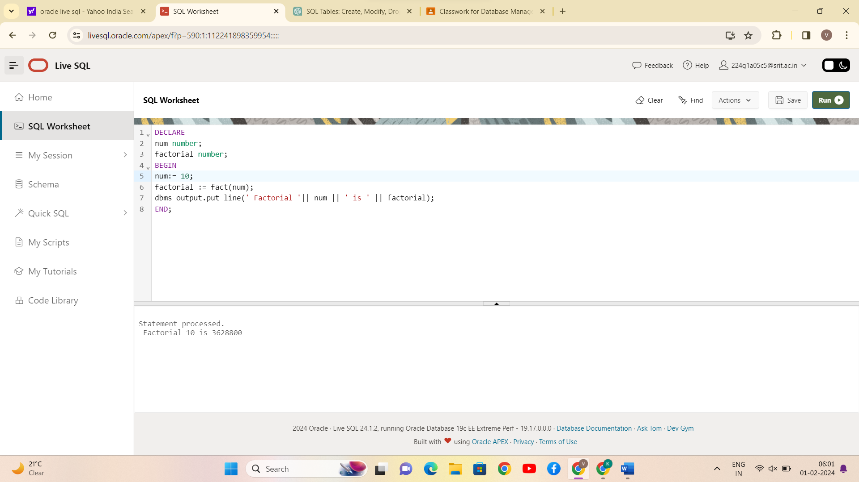

CONCLUSION:

PL/SQL program to implement Stored Function on table is successfully completed.

15. Write PL/SQL program to implement Trigger on table.

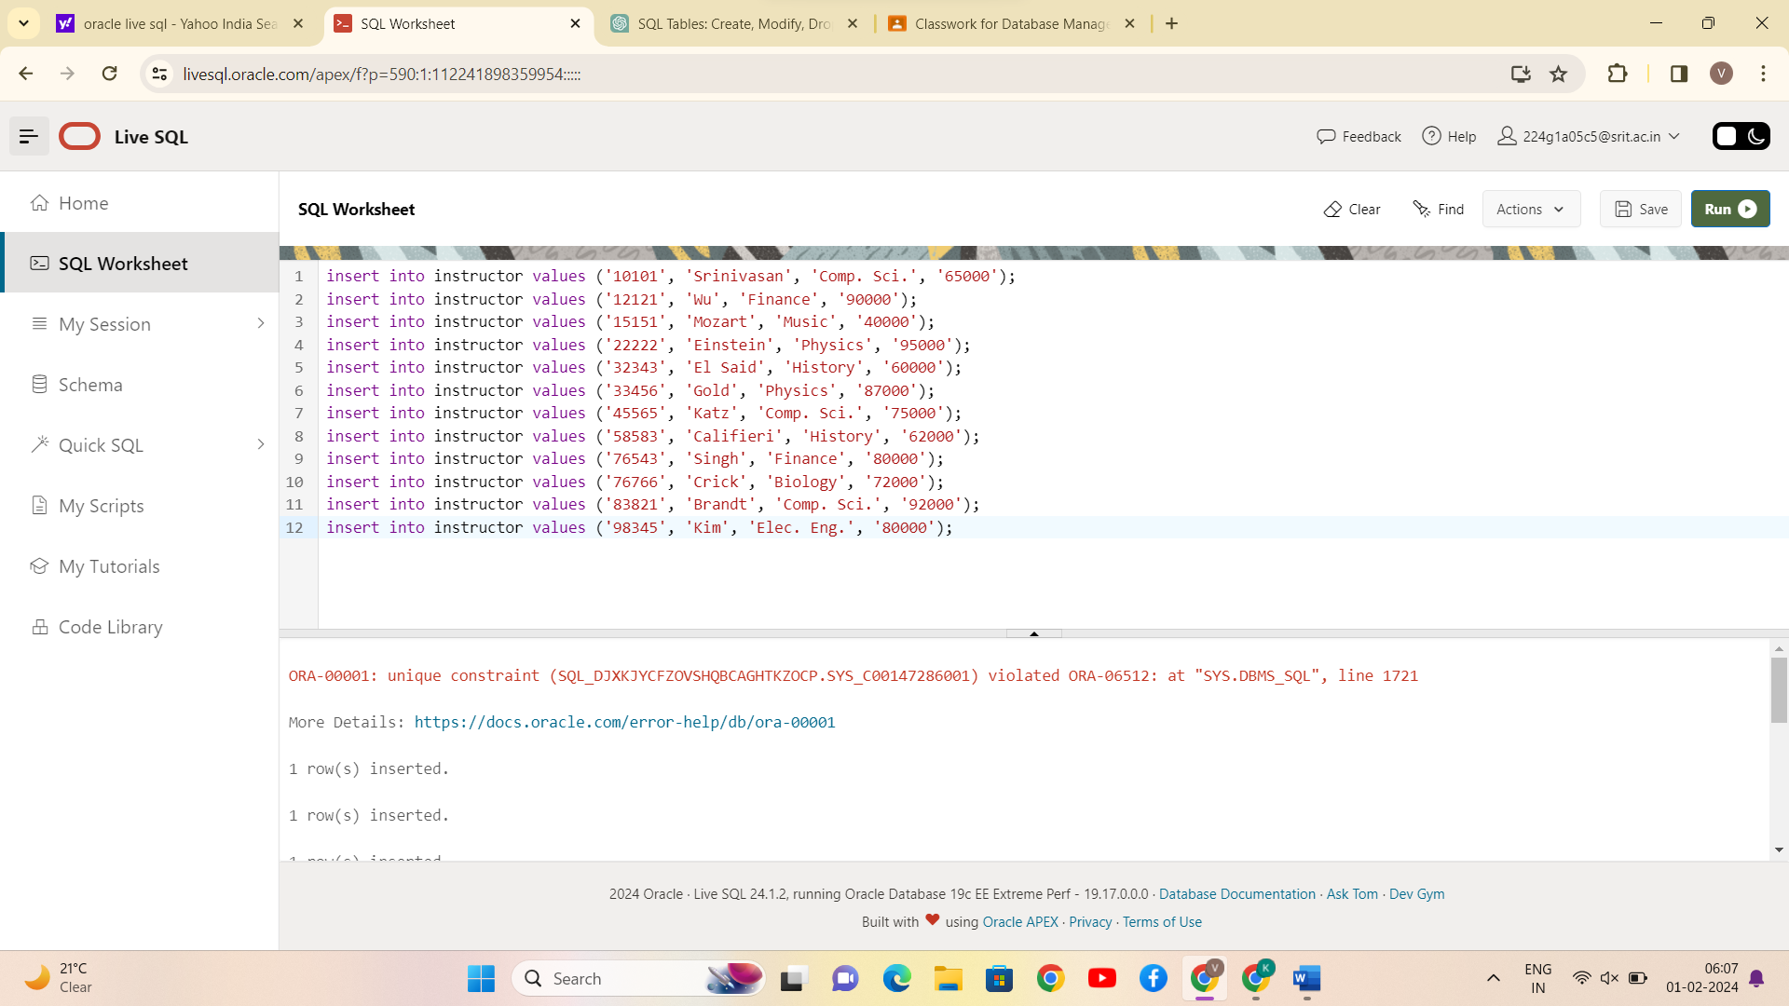

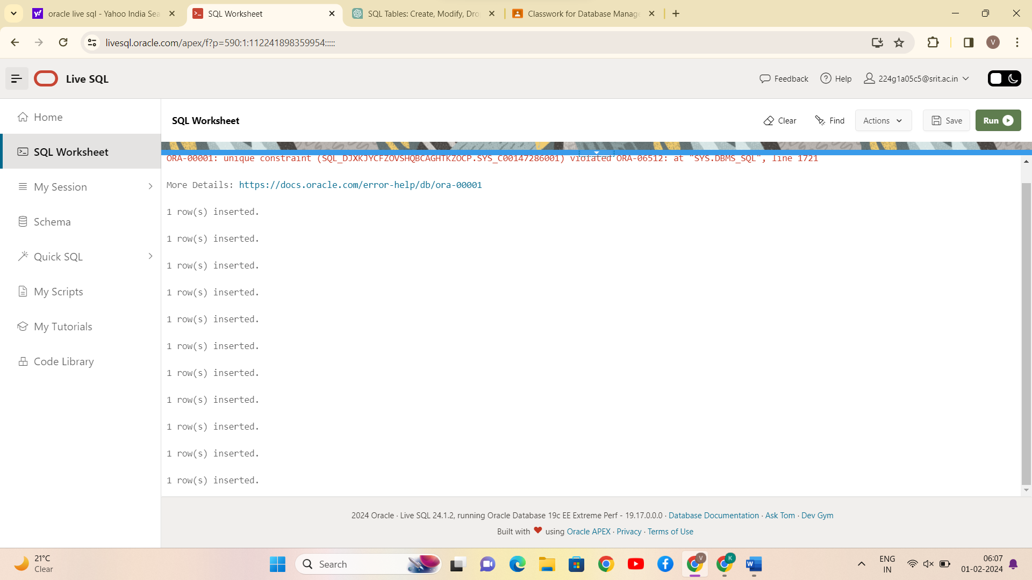

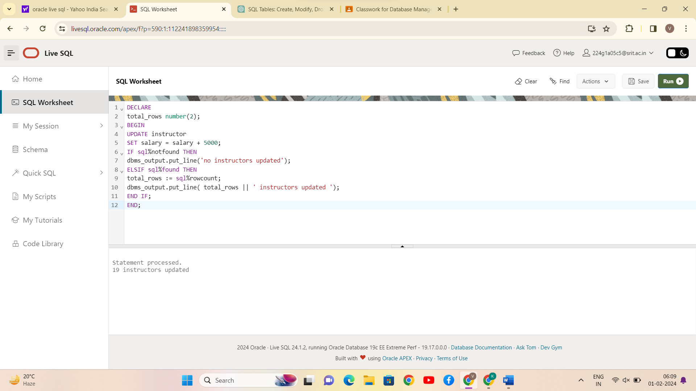

CONCLUSION:

PL/SQL program to implement Trigger on table is successfully completed.

16. Write PL/SQL program to implement Cursor on table.

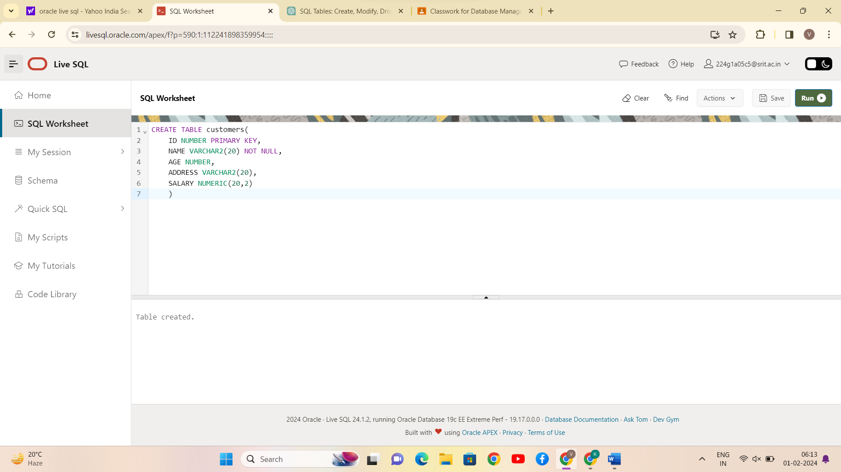

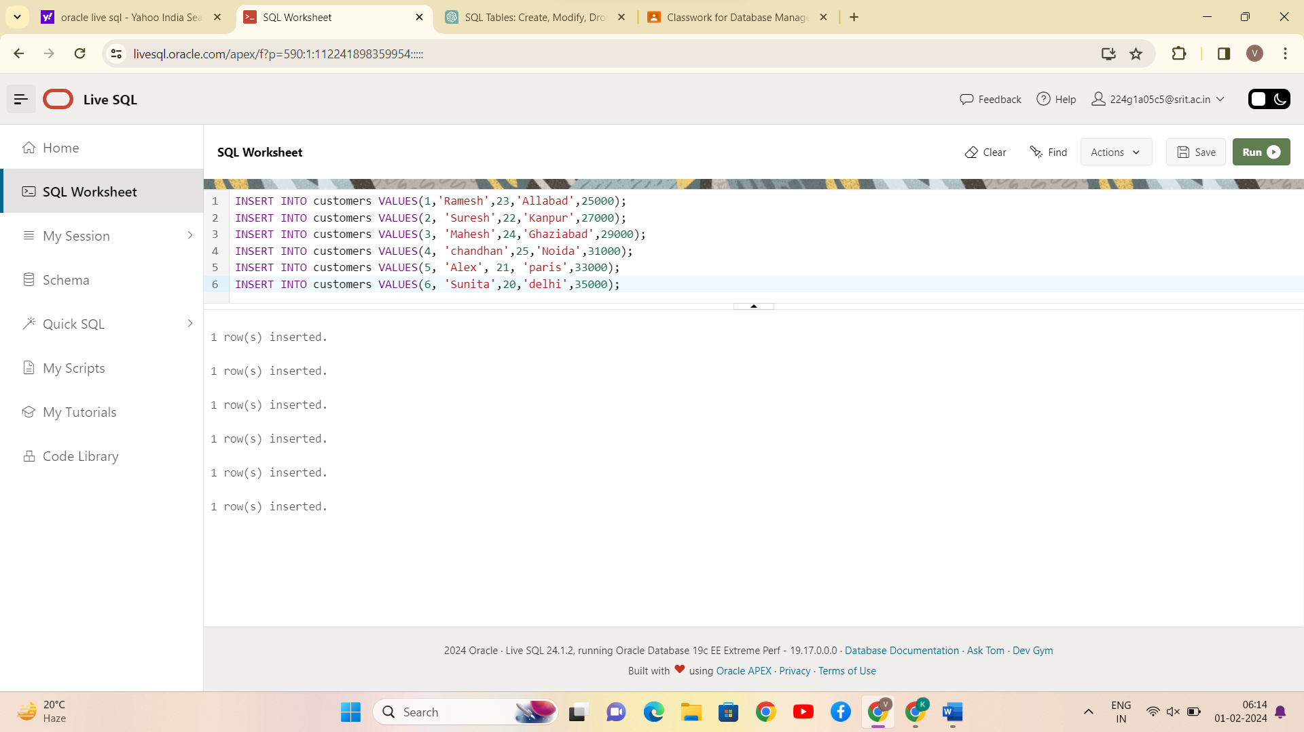

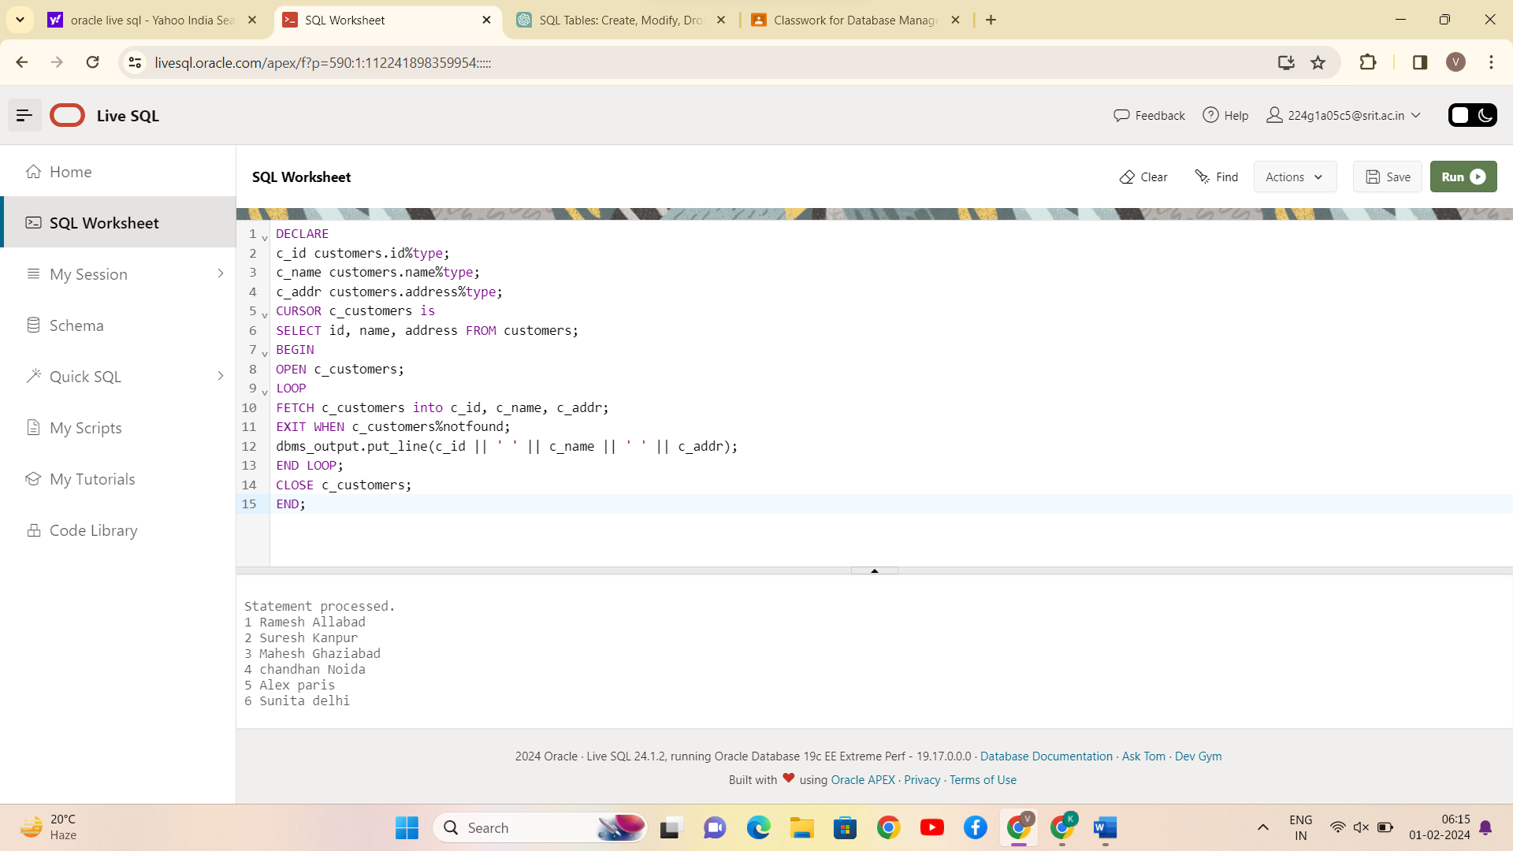

CONCLUSION:

PL/SQL program to implement Cursor on table is successfully completed.